CSIT314 Software Development Methodologies - Group Project

Sprint 2 - US13: Interior designer log in
Interior Design Platform - Interior Designer
All diagrams were drawn in draw.io. Open "US13 Interior designer log in.drawio" in this folder to edit them - each diagram is its own page in that file. The exported images are in the "diagrams" folder.

Assumptions
- The system is the Interior Design Platform from the project specification. Sprint 2 covers the Interior Designer's stories (log in, company profile and log out, US13 - US19) and the Platform Manager's log in (US39).
- An Interior Designer is a user account whose user profile is Active and has both the "Manage company profile" and "Manage own IDPs" permissions. We check the permissions, not the profile name. So a custom profile with those two permissions can also log in as a designer.
- We follow B-C-E: the actor only talks to the boundary (page), the boundary only talks to the controller, and the controller works with the entity classes. There is one controller per use case.
- The designer's user account is made by the User Admin first (UC8). US13 reuses the existing UserAccount and UserProfile entity classes, so no new table is needed.
- Designers have their own login page (/designer/login). The shared login page from US1 (/login) also sends a designer to the designer dashboard.
- Every failed login shows the same message, so the page doesn't tell anyone whether the username exists or the account is suspended.
- When the login works, the old session is cleared and only userId, profileId and username are saved. The password is never saved in the session.
- The designer dashboard checks the account and profile again every time it is opened. If the account or profile is suspended after login, the dashboard shows "Access unavailable" (HTTP 403).
- Designers can't open the User Admin pages (e.g. /accounts) - they get HTTP 403.

1. User story
Story ID | US13
User story | As an interior designer, I want to log in so that I can manage my company's information and IDPs.
Actor | Interior Designer
Priority | High
Story points (estimate) | 3
Acceptance criteria | 1. Given I open the designer login page, then I see a username and password form.  2. Given my username and password are correct and my account and profile are Active, when I click "Log in", then I go to the designer dashboard and see "Welcome back, <username>".  3. Given I leave the username or password empty, then I see "Please enter your username and password".  4. Given the password is wrong, the username doesn't exist, my account or profile is suspended, or my account is not an interior designer, then I see "Invalid login details or access unavailable" and I am not logged in.  5. The dashboard shows the Company Profile, Current IDPs and Past IDPs cards, and none of the User Admin pages.  6. Given I am not logged in, when I open the designer dashboard, then I am sent to the designer login page.
Tasks | T13.1 Write the use case description and draw the use case diagram  T13.2 Draw the B-C-E class diagram and the sequence diagram  T13.3 Draw the wireframes for the login form, the error messages and the designer dashboard  T13.4 Write the unit tests first (TDD) for InteriorDesignerLoginController and InteriorDesignerLoginPage  T13.5 Code InteriorDesignerLoginController: login(), isInteriorDesigner() and getAuthenticatedDesigner()  T13.6 Code InteriorDesignerLoginPage, the designer login page and the designer dashboard  T13.7 Update the shared US1 login so designers go to their own dashboard, and block designers from the admin pages  T13.8 Run the test cases, fix bugs and push to the repo so the CI pipeline runs the unit tests

2. Use case diagram
The user story becomes one use case, UC13 Interior designer log in. The Interior Designer is the only actor.
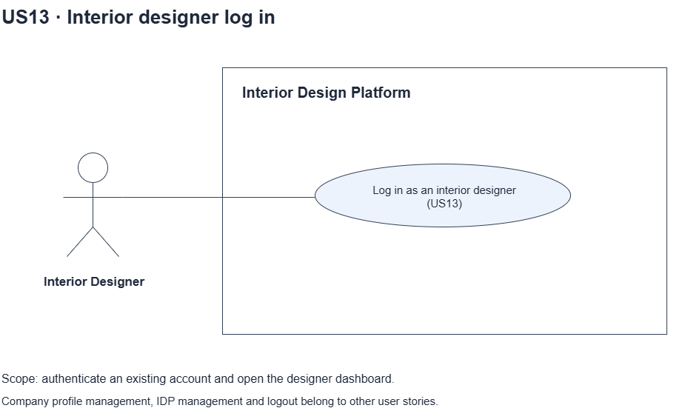
Figure 1: Use case diagram for US13 Interior designer log in

3. Use case description
Use case | UC13 Interior designer log in
Actor | Interior Designer
Brief description | The Interior Designer logs in with their username and password so they can use the designer dashboard.
User story | US13: As an interior designer, I want to log in so that I can manage my company's information and IDPs.
Preconditions | The designer has a user account made by the User Admin (UC8).  The account's user profile has the "Manage company profile" and "Manage own IDPs" permissions.
Trigger | The Interior Designer opens the designer login page.
Basic flow | 1. The Interior Designer opens the designer login page.  2. The system shows the login form.  3. The Interior Designer types their username and password and clicks "Log in".  4. The system checks that both fields are filled in.  5. The system checks the username and password.  6. The system checks that the account and its user profile are Active and that the profile has both designer permissions.  7. The system starts a new session and shows the designer dashboard with "Welcome back, <username>".
Alternative flows | 4a. A field is empty: the system shows "Please enter your username and password". Back to step 3.  5a. The username or password is wrong: the system shows "Invalid login details or access unavailable". Back to step 3.  6a. The account or profile is suspended, or the profile doesn't have the designer permissions: the system shows the same message "Invalid login details or access unavailable". Back to step 3.
Postconditions | The Interior Designer is logged in. The session holds userId, profileId and username.  The designer dashboard is shown.

4. Wireframes
The wireframes were drawn in draw.io. They are low-fidelity: they show the layout and the flow, not the final colours. The orange numbers match the notes under each screen.

4a - Log in form
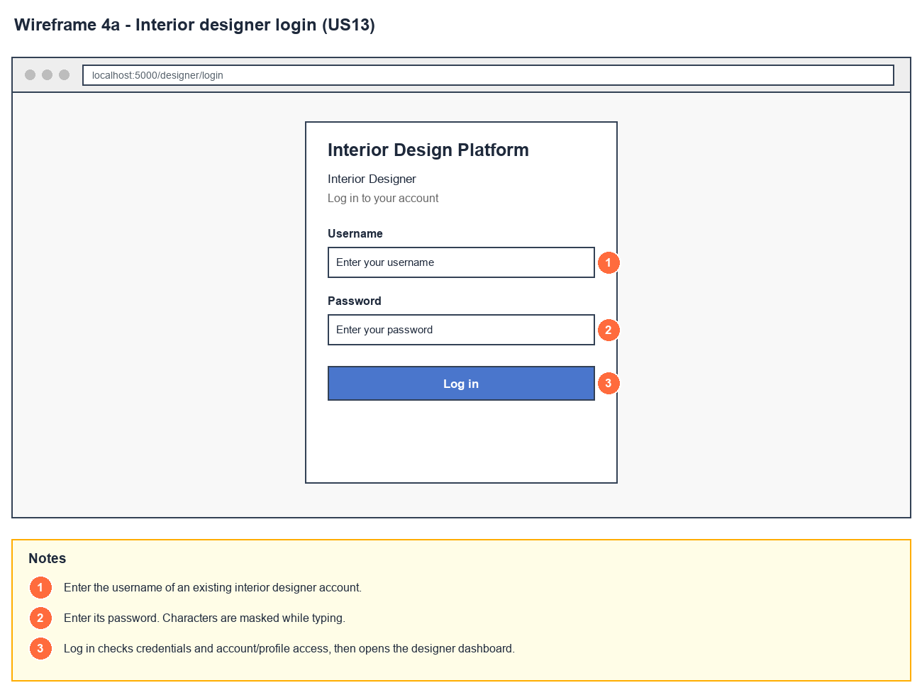
Figure 2: Wireframe 4a - Log in form (US13)

4b - Missing required fields
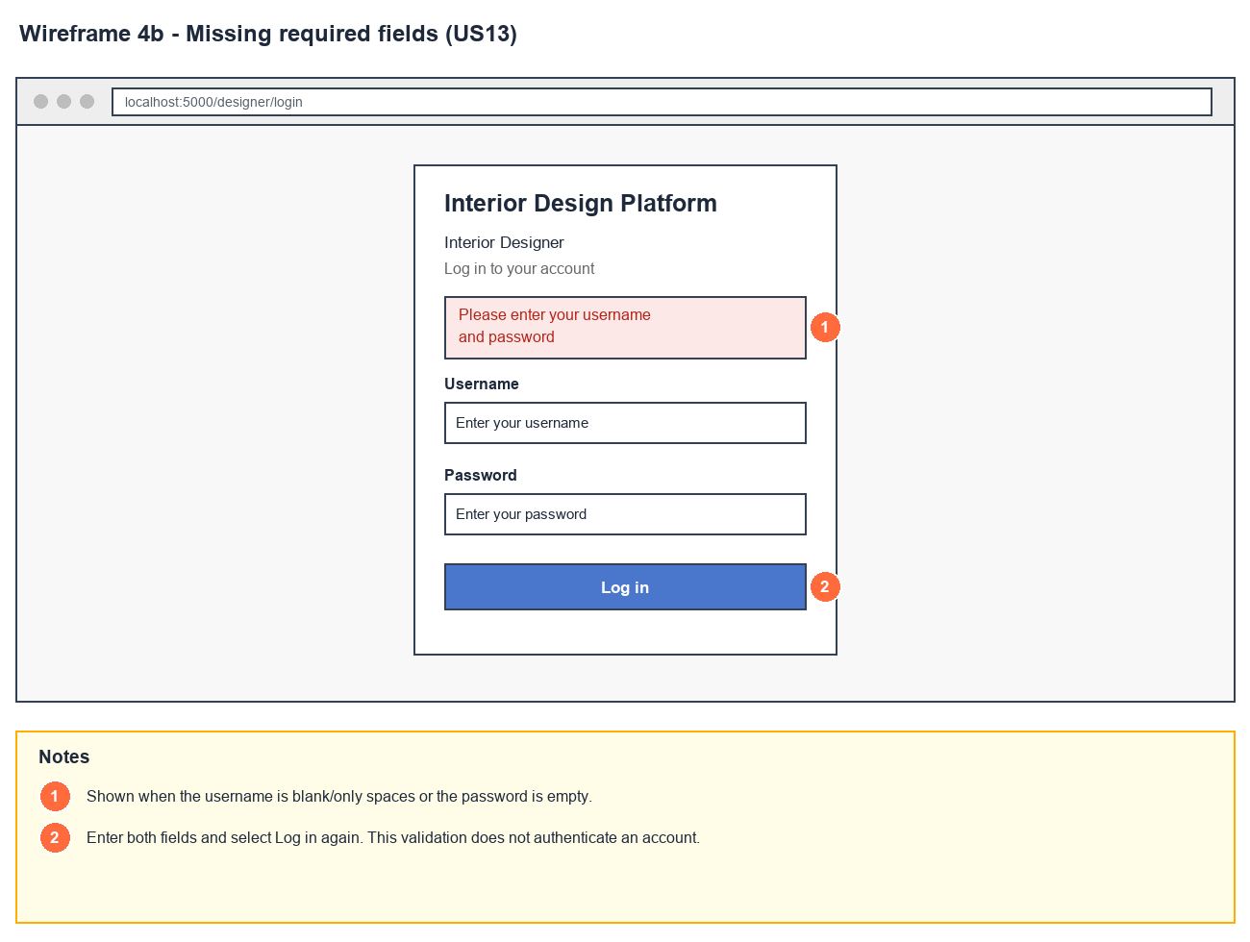
Figure 3: Wireframe 4b - Missing required fields (US13)

4c - Invalid login
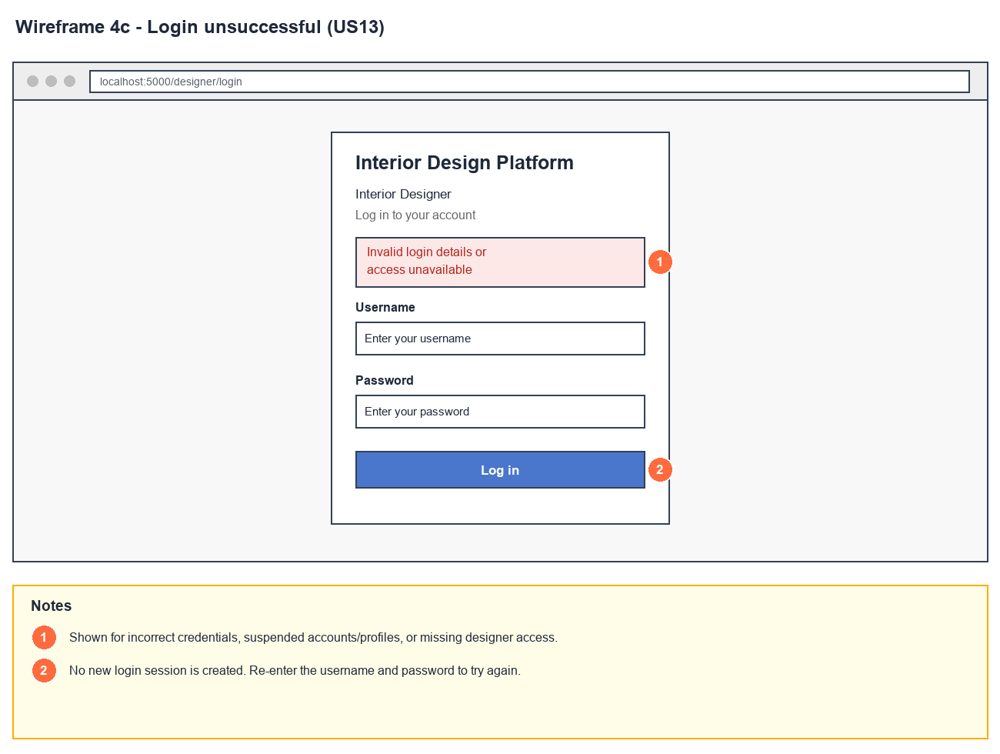
Figure 4: Wireframe 4c - Invalid login (US13)

4d - Designer dashboard
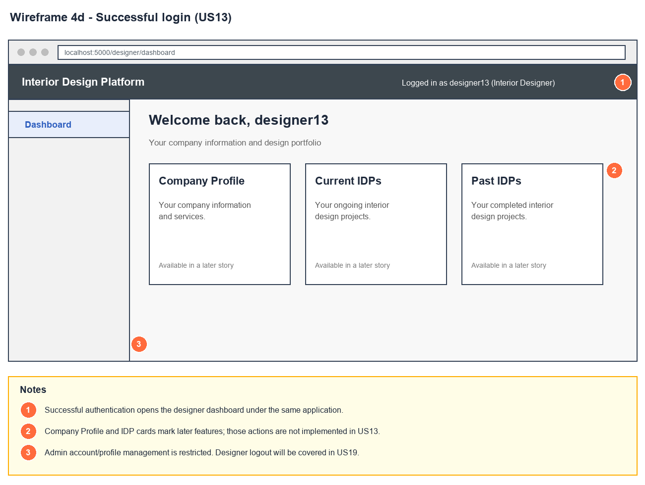
Figure 5: Wireframe 4d - Designer dashboard (US13)

5. B-C-E class diagram
The solid line means the boundary calls the controller. The dashed lines mean the controller uses the other classes. Only the operations needed for this use case are shown.
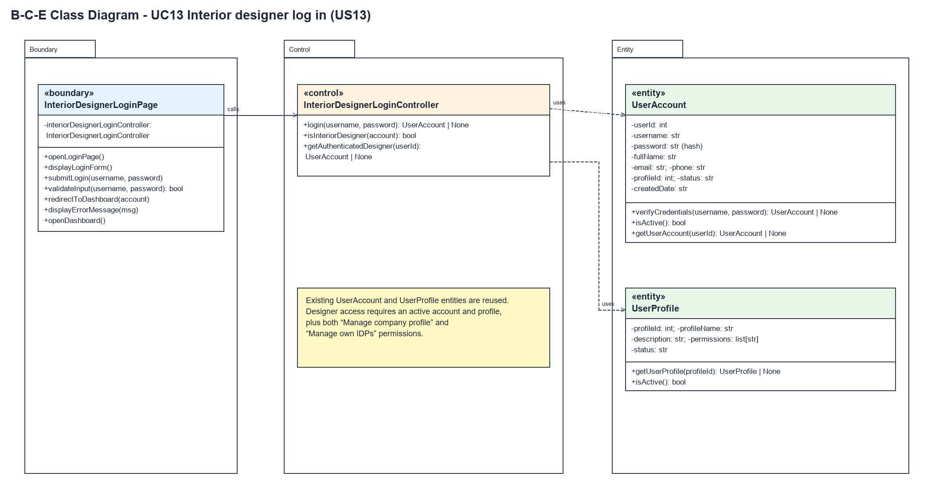
Figure 6: B-C-E class diagram for US13 Interior designer log in
Layer | Class | What it does
Boundary | InteriorDesignerLoginPage | The designer login page and dashboard. Checks both fields are filled in (validateInput), sends the username and password to the controller, starts the session (redirectToDashboard) and shows the messages. openDashboard() checks access again every time the dashboard is opened.
Control | InteriorDesignerLoginController | Controller for UC13. login() asks UserAccount to check the credentials, then isInteriorDesigner() checks the account and profile are Active and the profile has both designer permissions. getAuthenticatedDesigner() is reused by US14 - US18 to check access on every designer page.
Entity | UserAccount | The existing user account (US1). verifyCredentials() checks the username and hashed password, isActive() checks the account status and getUserAccount() loads the logged-in account.
Entity | UserProfile | The existing user profile (US3). getUserProfile() loads the account's profile, isActive() checks its status and its permissions list holds the designer permissions.

6. Sequence diagram
The sequence diagram follows UC13. The page shows the form (step 2) and checks the input when it is submitted (step 4). The outer alt splits a missing field (alternative flow 4a) from filled-in input. For filled-in input, the controller asks UserAccount to check the username and password (step 5). Then isInteriorDesigner() checks the account, the profile and the permissions inside the nested opt boxes (step 6). The last alt shows the designer dashboard (step 7) or the same error message for every kind of failure (alternative flows 5a and 6a).
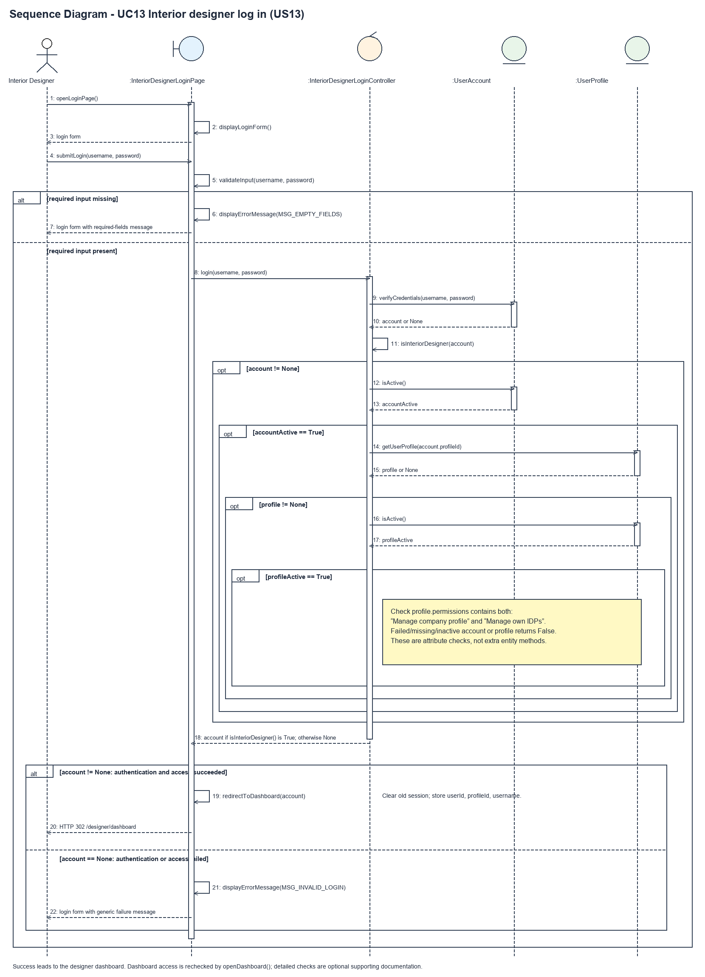
Figure 7: Sequence diagram for UC13 Interior designer log in

7. Test cases
Test data used below (same as database/seedData.py and the test files): user profiles User Admin (id 1), Interior Designer (id 2), Customer (id 3) and Platform Manager (id 4), all Active. User accounts admin01 / Admin@123 (User Admin) and cust001 / Cust@123 (Customer). The designer account designer13 / Design@123 (Tengku Uda Designer, Interior Designer profile) is made first with UC8.

7a. System test cases (black box)
Equivalence partitioning and boundary value analysis were used to pick the test data. Fill in "Actual result" and "Pass/Fail" after running each test.
Test ID | Scenario | Prerequisites | Test steps | Test data | Expected result | Actual result | Pass / Fail
TC13.1 | Valid designer login | designer13 exists and is Active. | 1. Open /designer/login  2. Type the username and password  3. Click "Log in" | designer13 / Design@123 | Designer dashboard with "Welcome back, designer13" and the Company Profile, Current IDPs and Past IDPs cards.
TC13.2 | Both fields empty | None. | 1. Open /designer/login  2. Leave both fields empty  3. Click "Log in" | (empty) / (empty) | "Please enter your username and password". Not logged in.
TC13.3 | Wrong password | designer13 exists. | 1. Open /designer/login  2. Type the wrong password  3. Click "Log in" | designer13 / Wrong@123 | "Invalid login details or access unavailable". Not logged in.
TC13.4 | Username does not exist | None. | 1. Open /designer/login  2. Type the details  3. Click "Log in" | nobody13 / Design@123 | "Invalid login details or access unavailable".
TC13.5 | Suspended account | designer13 has been suspended (UC11). | 1. Open /designer/login  2. Type the details  3. Click "Log in" | designer13 / Design@123 | "Invalid login details or access unavailable". Not logged in.
TC13.6 | Not an interior designer | None. | 1. Open /designer/login  2. Log in as the User Admin | admin01 / Admin@123 | "Invalid login details or access unavailable". Not logged in.
TC13.7 | Shared login page sends a designer to the designer dashboard | designer13 exists. | 1. Open /login  2. Log in as designer13 | designer13 / Design@123 | The designer dashboard is shown, not the User Admin dashboard.
TC13.8 | Dashboard without logging in | Not logged in. | 1. Open /designer/dashboard | - | Sent to the designer login page.
TC13.9 | Designer can't open User Admin pages | Logged in as designer13. | 1. Open /accounts | - | Access is refused (HTTP 403).

7b. Unit test cases (for TDD)
These are written before the code (test-driven development) and run automatically in the CI pipeline. They cover normal inputs, abnormal inputs and boundary values. Each one matches a test function in tests/test_us13_interiorDesignerLogin.py (e.g. UT13.1 is test_ut13_1_...). Pass / Fail is from the pytest run on 23 October 2026.
Test ID | Class and method | Input / setup | Expected output | Type | Pass / Fail
UT13.1 | InteriorDesignerLoginController.login() | "designer13", "Design@123" | Returns the account (username designer13, profileId 2) | Normal | Pass
UT13.2 | InteriorDesignerLoginController.login() | "designer13", "Wrong@123" | Returns None | Abnormal | Pass
UT13.3 | InteriorDesignerLoginController.login() | "nobody13", "Design@123" | Returns None | Abnormal | Pass
UT13.4 | InteriorDesignerLoginController.login() | designer13 with the account suspended | Returns None | Abnormal | Pass
UT13.5 | InteriorDesignerLoginController.login() | designer13 with the Interior Designer profile suspended | Returns None | Abnormal | Pass
UT13.6 | InteriorDesignerLoginController.login() | "admin01", "Admin@123" (User Admin) | Returns None | Abnormal | Pass
UT13.7 | InteriorDesignerLoginController.login() | "cust001", "Cust@123" (Customer) | Returns None | Abnormal | Pass
UT13.8 | InteriorDesignerLoginController.login() | Profile only has "Manage company profile" | Returns None (both permissions needed) | Boundary | Pass
UT13.9 | UserAccount.verifyCredentials() | "designer13", "Design@123" | Returns the account. The saved password is a hash, not "Design@123" | Normal | Pass
UT13.10 | InteriorDesignerLoginPage.validateInput() | "", "Design@123" | Returns false | Boundary | Pass
UT13.11 | InteriorDesignerLoginPage.validateInput() | "designer13", "" | Returns false | Boundary | Pass
UT13.12 | InteriorDesignerLoginPage.validateInput() | " " (spaces only), "Design@123" | Returns false | Boundary | Pass
UT13.13 | InteriorDesignerLoginPage.validateInput() | "designer13", "Design@123" | Returns true | Normal | Pass
UT13.14 | InteriorDesignerLoginPage.openLoginPage() | GET /designer/login | Page shows "Interior Designer" and the username and password fields | Normal | Pass
UT13.15 | InteriorDesignerLoginPage.submitLogin() | POST designer13 / Design@123 | Redirects to /designer/dashboard. Session has userId, profileId 2 and username, but no password | Normal | Pass
UT13.16 | InteriorDesignerLoginPage.submitLogin() | POST designer13 / Wrong@123 | "Invalid login details or access unavailable". No userId in the session | Abnormal | Pass
UT13.17 | InteriorDesignerLoginPage.submitLogin() | POST empty username and password | "Please enter your username and password" | Boundary | Pass
UT13.18 | InteriorDesignerLoginPage.submitLogin() | POST with the account suspended | "Invalid login details or access unavailable". No userId in the session | Abnormal | Pass
UT13.19 | InteriorDesignerLoginPage.openDashboard() | Logged in as designer13 | "Welcome back, designer13", Company Profile, Current IDPs and Past IDPs. No "User Accounts" | Normal | Pass
UT13.20 | InteriorDesignerLoginPage.openDashboard() | Not logged in | Redirects to /designer/login | Abnormal | Pass
UT13.21 | InteriorDesignerLoginPage.openDashboard() | Profile suspended after logging in | HTTP 403 | Abnormal | Pass
UT13.22 | loginRequired (app.py) on /accounts | Logged in as designer13 | HTTP 403 | Abnormal | Pass
UT13.23 | LoginPage.redirectToDashboard() (shared /login) | POST designer13 / Design@123 | Redirects to /designer/dashboard | Normal | Pass
UT13.24 | LoginPage.redirectToDashboard() (shared /login) | POST admin01 / Admin@123 | Redirects to /dashboard and /accounts still opens | Normal | Pass

